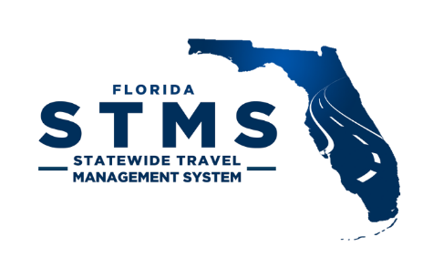
STMS Account Request
Add, Remove, or Modify STMS User
Mail completed form to: accounting@justiceadmin.org State Employee
☐ Add New Employee ☐ Modify Existing Employee ☐ Remove Existing Employee

Employee Information
First Name: Last Name:
Email:
PF ID (Log-in Number, not Employee ID):
FLAIR Org Code (default):
Title:
STMS Profile:
☐ Traveler ☐ Proxy Traveler ☐ Preparer
☐ Fiscal Accountant ☐ Auditor ☐ Reporter
If Approver, type:
☐ Reviewer ☐ Payment Approver
☐ Agency Head/Delegate Approver
Supervisor (first approver) in STMS:

STMS access approved by Supervisor: ☐
Office (CCRC, GAL, PD, RC, or SA):
Headquarters Information
City:
☐ HQ is Home
Misc.
☐ Leadership (for Quarterly Senior Management Report)
The following indicators will be pulled from People First:
Sworn Protected Restricted Restricted Relative
Enter applicable indicator:________________________
Name of Person Making the Request:

Signature __________________________________________
Title:

